**Event’s page**

**Sunday Variety Concert**

Presented by Friends of the Theatre

2pm Sunday 26 April

Pimlico Performing Arts Centre on Fulham Road

Any Enquiries please phone 4723 7879

**Harbourside Duo**

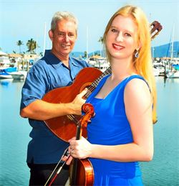

Presents Dream Serenade. Music of Debussy, Ravel, Saint- Saens, Sibelius and others.

March into Sommarhagen! Dance the Habanera with the Girl with Flaxen Hair!

Be seduced by Thais! Or just relax and let the music wash over you.

2pm Sunday 17 May at C2 (Townsville Civic Theatre)

**Aviva String Quartet**

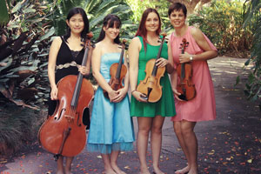

Following the phenomenal success of their 2014 season, they return with their first concert for 2015, bringing their signature style of classical and modern music to the masses in their own fresh and entertaining style.

Featuring:

* Caroline Lloyd-Doolan on violin
* Susan Fraser on violin
* Jessica Winton on viola
* Ivy Wu on cello

2pm Sunday 14 June at C2 (CivicTheatre building)

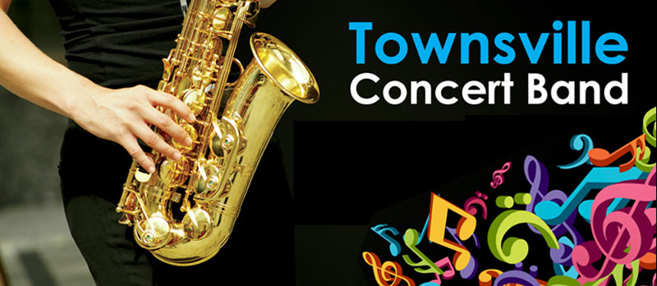

2pm Sunday 27 September June at C2 (Townsville Civic Theatre)

**Voices of Pimlico**

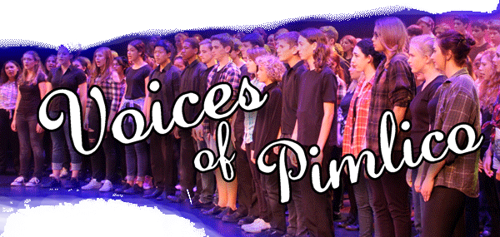

2pm Sunday 6 September at C2 (Townsville Civic Theatre)

**Townsville Concert Band**



2pm Sunday 27 September June at C2 (Townsville Civic Theatre)

**Allegro Choir**

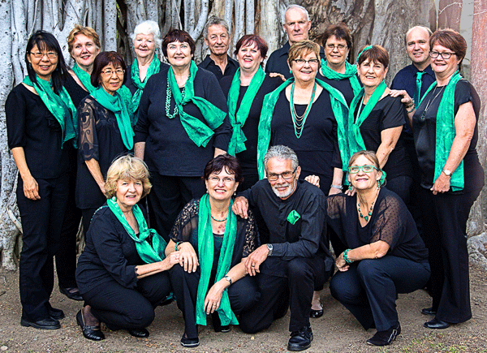

2pm Sunday 22 November at C2 (Townsville Civic Theatre)

**Aviva String Quartet**

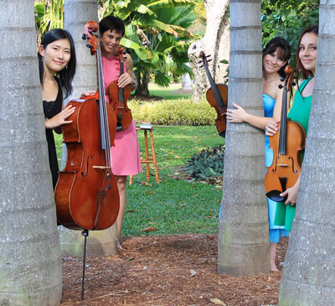

The Aviva String Quartet return with their final concert for 2015, bringing their signature style of classical and modern music to the masses in their own fresh and entertaining style.

2pm Sunday 29 November at C2 (Townsville Civic Theatre)